# Business Intelligence Concepts and Application

2

Learning Objectives

* Understand the concept of Business Intelligence and its role in decision-making
* Understand the two major types of decisions
* Know about the type and range of tools for Business Intelligence
* Outline the wide range of applications of Business Intelligence across industry domains

### INTRODUCTION

Business Intelligence (BI) is an umbrella term that includes a variety of IT applications that are used to analyze an organization’s data and communicate the information to relevant users.



Mining

Data

Intelligence

Business

FIGURE: BIDM Cycle

The nature of life and businesses is to grow. Information is the lifeblood of business. They use many techniques for understanding their environment and predicting the future for their own benefit and growth. Decisions are made from facts and feelings. Data-based decisions are more effective than those based on feelings alone. Actions based on accurate data, information, knowledge, experimentation, and testing, using fresh insights, can more likely succeed and lead to sustained growth. One’s own data can be the most effective teacher. Therefore, organizations should gather data, sift through it, analyze and mine it, find in- sights, and then embed those insights into their operating procedures.

There is a new sense of importance and urgency around data as it is being viewed as a new natural resource. It can be mined for value, insights, and competitive advantage. In a hyperconnected world where everything is potentially connected to everything else; with potentially infinite correlations, data represents the impulses of nature in the form of certain events and attributes. A skilled businessperson is motivated to use this cache of data to harness nature, and to find new niches of unserved opportunities that could become profitable ventures.

#### Caselet: Khan Academy – BI in Education

*Khan Academy is an innovative non-profit educational organization that is turning the K-12 education system upside down. It provides short YouTube based video lessons on thousands of topics for free. It shot into prominence when Bill Gates promoted it as a resource that he used to teach his own children. With this kind*

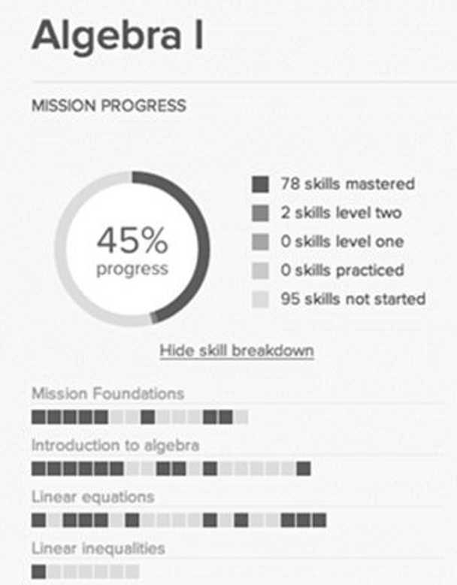

FIGURE

*of a resource, classrooms are being flipped, i.e., students do their basic lecture-type learning at home using those videos, while the class time is used for more one-on- one problem solving and coaching. Students can access the lessons at any time to learn at their own pace. The students’ progress is recorded including what videos they watched and how many times, which problems they stumbled on, and what scores they got on online tests.*

*Khan Academy has developed tools to help teachers get a pulse on what’s happening in the classroom. Teachers are provided a set of real-time dashboards as shown in Figure to give them information from the macro level (“How is my class doing on geometry?”) to the micro level (“How is Jane doing on mastering polygons?”). Armed with this information, teachers can place selective focus on the students that need certain help. (Source: *KhanAcademy.org*)*

1. *How does a dashboard improve the teaching experience and the student’s learning experience?*
2. *Design a dashboard for tracking your own career.*

### BI FOR BETTER DECISIONS

The future is inherently uncertain. Risk is the result of a probabilistic world where there are no certainties and complexities abound. People use crystal balls, astrology, palmistry, ground hogs, and mathematics and numbers to mitigate risk in decision-making. The goal is to make effective decisions, while reducing risk. Businesses calculate risks and make decisions based on a broad set of facts and insights. Reliable knowledge about the future can help managers make the right decisions with lower levels of risk.

The speed of action has risen exponentially with the growth of the Internet. In a hypercompetitive world, the speed of a decision and the consequent action can be a key advantage. The Internet and mobile technologies allow decisions to be made anytime, anywhere. Ignoring fast-moving changes can threaten the organization’s future. Research has shown that an unfavorable comment about the company and its products on social media should not go unaddressed for long. Banks have had to pay huge penalties to Consumer Financial Protection Bureau (CFPB) in United States in 2013 for complaints made on CFPB’s websites. On the other hand, a positive sentiment expressed on social media should also be utilized as a potential sales and promotion opportunity, while it lasts.

### DECISION TYPES

There are two main kinds of decisions – strategic decisions and operational decisions. BI can help make both better. Strategic decisions are those that impact

the direction of the company. The decision to reach out to a new customer set would be a strategic decision. Operational decisions are more routine and tactical decisions, focused on developing greater efficiency. Updating an old website with new features will be an operational decision.

In strategic decision-making, the goal itself may or may not be clear, and the same is true for the path to reach the goal. The consequences of the decision would be apparent sometime later. Thus, one is constantly scanning for new possibilities and new paths to achieve the goals. BI can help with what-if analysis of many possible scenarios. BI can also help create new ideas based on new patterns found from data mining.

Operational decisions can be made more efficient using an analysis of past data. A classification system can be created and modeled using the data of past instances to develop a good model of the domain. This model can help improve operational decisions in the future. BI can help automate operation level decision-making and improve efficiency by making millions of microlevel operational decisions in a model-driven way. For example, a bank might want to make decisions about making financial loans in a more scientific way using data-based models. A decision-tree-based model can provide consistently accurate loan decisions. Developing such decision tree models is one of the main applications of data mining techniques.

Effective BI has an evolutionary component as business models evolve. When people and organizations act, new facts (data) are generated. Current business models can be tested against the new data and it is possible that those models will not hold up well. In that case, decision models should be revised, and new insights should be incorporated. An unending process of generating fresh new insights in real time can help make better decisions, and thus can be a significant competitive advantage.

### BI TOOLS

BI includes a variety of software tools and techniques to provide the managers with the information and insights needed to run the business. Information can be provided about the current situation with the capability to drill down into details, and insights about emerging patterns which lead to projections into the future. BI tools include data warehousing, online analytical processing, social media analytics, reporting, dashboards, querying, and data mining.

BI tools can range from very simple tools that could be considered end-user tools, to very sophisticated tools that offer a very broad and complex set of

functionality. Thus, even executives can be their own BI experts, or they can rely on BI specialists to set up the mechanism for them. Thus, large organizations invest in expensive sophisticated BI solutions that provide good information in real time.

A spreadsheet tool, such as Microsoft Excel, can act as an easy but effective BI tool by itself. Data can be downloaded and stored in the spreadsheet, then analyzed to produce insights and presented in the form of graphs and tables. This system offers limited automation using macros and other features. The analytical features include basic statistical and financial functions. Pivot tables help do sophisticated what-if analysis. Add-on modules can be installed to enable moderately sophisticated statistical analysis.

A dashboarding system, such as IBM Cognos or Tableau, can offer a sophisticated set of tools for gathering, analyzing, and presenting data. At the user end, modular dashboards can be designed and redesigned easily with a graphical user interface. The back-end data analytical capabilities include many statistical functions. The dashboards are linked to data warehouses at the back end to ensure that the tables and graphs and other elements of the dashboard are updated in real time.

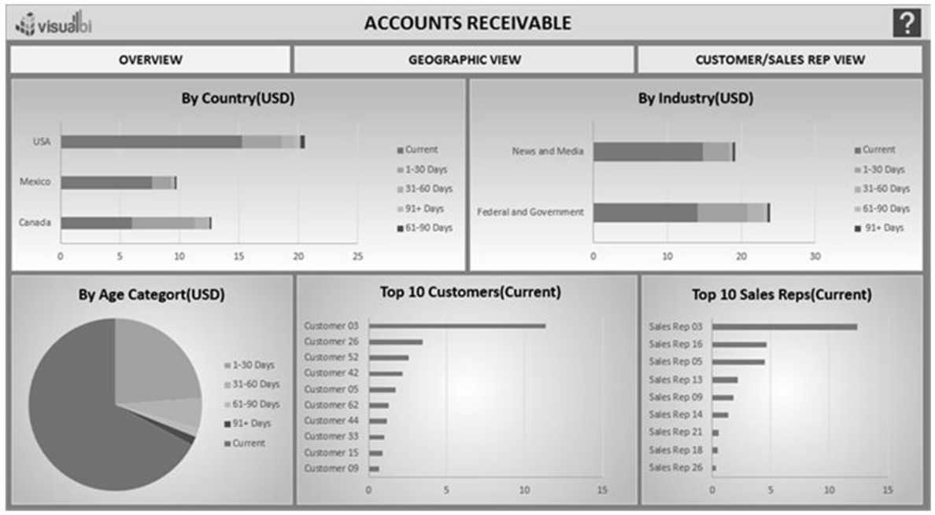

FIGURE: Sample Executive Dashboard

Data mining systems, such as IBM SPSS Modeler, are industrial strength systems that provide capabilities to apply a wide range of analytical models on large datasets. Open source systems, such as Weka, are popular platforms designed to help mine large amounts of data to discover patterns.

### BI SKILLS

As data grows and exceeds our capacity to make sense of it, the tools need to evolve, and so should the imagination of the BI specialist.

A skilled and experienced BI specialist should be open enough to go outside the box, open the aperture and see a wider perspective that includes more dimensions and variables, in order to find important patterns and insights. The problem needs to be looked at from a wider perspective to consider many more angles that may not be immediately obvious. An imaginative solution should be proposed for the problem so that interesting and useful results can emerge.

A good data mining project begins with an interesting problem to solve. Selecting the right data mining problem is an important skill. The problem should be valuable enough that solving it would be worth the time and expense. It takes a lot of time and energy to gather, organize, cleanse, and prepare the data for mining and other analysis. The data miner needs to persist with the exploration of patterns in the data. The skill level must be deep enough to engage with the data and make it yield new useful insights.

### BI APPLICATIONS

BI tools are required in almost all industries and functions. The nature of the information and the speed of action may be different across businesses, but every manager today needs access to BI tools to have up-to-date metrics about business performance. Businesses need to embed new insights into their operating processes to ensure that their activities continue to evolve with more efficient practices. The following are some areas of applications of BI and data mining.

### Customer Relationship Management

A business exists to serve a customer. A happy customer becomes a repeat customer. A business should understand the needs and sentiments of the customer, sell more of its offerings to the existing customers, and expand the pool of customers it serves. BI applications can impact many aspects of marketing.

*Maximize the Return on Marketing Campaigns* Understanding the customer’s pain points from data-based analysis can ensure that the marketing messages are fine-tuned to better resonate with customers.

*Improve Customer Retention (Churn Analysis)* It is more difficult and expensive to win new customers than it is to retain existing customers. Scoring each customer on their likelihood to quit can help the business design effective interventions, such as discounts or free services to retain profitable customers in a cost-effective manner.

*Maximize Customer Value (Cross-selling, Up-selling)* Every contact with the customer should be an opportunity to gauge their current needs. Offering a customer new products and solutions based on those imputed needs can help increase revenue per customer. Even a customer complaint be an opportunity to wow the customer. Using the knowledge of the customer’s history and value, the business can choose to sell a premium service to the customer.

*Identify and Delight Highly Valued Customers* By segmenting the customers, the best customers can be identified. They can be proactively contacted, and delighted, with greater attention and better service. Loyalty programs can be managed more effectively.

*Manage Brand Image* A business can create a listening post to listen to social media chatter about itself. It can then do sentiment analysis of the text to understand the nature of comments and respond appropriately to the prospects and customers.

### Healthcare and Wellness

Healthcare is one of the biggest sectors in advanced economies. Evidence-based medicine is the newest trend in data-based healthcare management. BI applications can help apply the most effective diagnoses and prescriptions for various ailments. They can also help manage public health issues and reduce waste and fraud.

*Diagnose Disease in Patients* Diagnosing the cause of a medical condition is the critical first step in a medical engagement. Accurately diagnosing cases of cancer or diabetes can be a matter of life and death for the patient. In addition to the patient’s own current situation, many other factors can be considered, including the patient’s health history, medication history, family history, and other environmental factors. This makes diagnosis as much of an art form as it is science. Systems, such as IBM Watson, absorb all the medical research to date and make probabilistic diagnoses in the form of a decision tree, along with

a full explanation for their recommendations. These systems take away most of the guess work done by doctors in diagnosing ailments.

*Treatment Effectiveness* The prescription of medication and treatment is also a difficult choice out of so many possibilities. For example, there are more than 100 medications for hypertension (high blood pressure) alone. There are also inter- actions in terms of which drugs work well with others and which drugs do not. Decision trees can help doctors learn about and prescribe more effective treatments. Thus, the patients can recover their health faster with a lower risk of complications and cost.

*Wellness Management* This includes keeping a track of patient’s health re- cords, analyzing customer health trends and proactively advising them to take any needed precautions.

*Manage Fraud and Abuse* Some medical practitioners have unfortunately been found to conduct unnecessary tests, and/or overbill the government and health insurance companies. Exception reporting systems can identify such providers and action can be taken against them.

*Public Health Management* The management of public health is one of the important responsibilities of any government. By using effective forecasting tools and techniques, governments can better predict the onset of diseases in certain areas in real time. They can thus be better prepared to fight against diseases. Google has been known to predict the movement of certain diseases by tracking the search terms (like flu, vaccine) used in different parts of the world.

### Education

As higher education becomes more expensive and competitive, it becomes a great user of data-based decision-making. There is a strong need for efficiency, increasing revenue, and improving the quality of student experience at all levels of education.

*Student Enrollment (Recruitment and Retention)* Marketing to new potential students requires schools to develop profiles of the students that are most likely to attend. Schools can develop models of what kinds of students are attracted to the school, and then reach out to those students. The students at risk of not returning can be flagged, and corrective measures can be taken in time.

*Course Offerings* Schools can use the class enrolment data to develop models of which new courses are likely to be more popular with students. This can help increase class size, reduce costs, and improve student satisfaction.

*Fund-Raising from Alumni and Other Donors* Schools can develop predictive models of the alumni that are most likely to pledge financial support to the school. Schools can create a profile for alumni more likely to pledge donations to the school. This can lead to a reduction in the cost of mailings and other forms of outreach to alumni.

### Retail

Retail organizations grow by meeting customer needs with quality products in a convenient, timely, and cost-effective manner. Understanding emerging customer shopping patterns can help retailers organize their products, inventory, store layout, and web presence in order to delight their customers, which in turn would help increase revenue and profits. Retailers generate a lot of transaction and logistics data that can be used to diagnose and solve problems.

*Optimize Inventory Levels at Different Locations* Retailers need to manage their inventories carefully. Carrying too much inventory imposes carrying costs, while carrying too little inventory can cause stock-outs and lost sales opportunities. Predicting sales trends dynamically help retailers move inventory to where it is most in demand. Retail organizations can provide their suppliers with real time information about sales of their items, so the suppliers can deliver their product to the right locations and minimize stock-outs.

*Improve Store Layout and Sales Promotions* A market basket analysis can develop predictive models of the products often sold together. This knowledge of affinities between products can help retailers co-locate those products. Alternatively, those affinity products could be located farther apart to make the customer walk the length and breadth of the store, and thus be exposed to other products. Promotional discounted product bundles can be created to push a non-selling item along with a set of products that sell well together.

*Optimize Logistics for Seasonal Effects* Seasonal products offer tremendously profitable short-term sales opportunities, yet they also offer the risk of unsold inventories at the end of the season. Understanding the products that are in season in which market can help retailers dynamically manage prices to ensure their inventory is sold during the season. If it is raining in a certain area, then the inventory of umbrella and ponchos could be rapidly moved there from non-rainy areas to help increase sales.

*Minimize Losses due to Limited Shelf Life* Perishable goods offer challenges in terms of disposing off the inventory in time. By tracking sales trends, the perishable products at risk of not selling before the sell-by date, can be suitably discounted and promoted.

### Banking

Banks make loans and offer credit cards to millions of customers. They are most interested in improving the quality of loans and reducing bad debts. They also want to retain better customers and sell more services to them.

*Automate the Loan Application Process* Decision models can be generated from past data that predict the likelihood of a loan proving successful. These can be inserted in business processes to automate the financial loan approval process.

*Detect Fraudulent Transactions* Billions of financial transactions happen around the world every day. Exception-seeking models can identify patterns of fraudulent transactions. For example, if money is being transferred to an unrelated account for the first time, it could be a fraudulent transaction.

*Maximize Customer Value (Cross-selling, Up-selling)* Selling more products and services to existing customers is often the easiest way to increase revenue. A checking account customer in good standing could be offered home, auto, or educational loans on more favorable terms than other customers, and thus, the value generated from that customer could be increased.

*Optimize Cash Reserves with Forecasting* Banks must maintain certain liquidity to meet the needs of depositors who may like to withdraw money. Using past data and trend analysis, banks can forecast how much to keep and invest the rest to earn interest.

### Financial Services

Stock brokerages are an intensive user of BI systems. Fortunes can be made or lost based on access to accurate and timely information.

*Predict Changes in Bond and Stock Prices* Forecasting the price of stocks and bonds is a favorite pastime of financial experts as well as lay people. Stock transaction data from the past, along with other variables, can be used to predict future price patterns. This can help traders develop long-term trading strategies.

*Assess the Effect of Events on Market Movements* Decision models using decision trees can be created to assess the impact of events on changes in market volume and prices. Monetary policy changes (such as Federal Reserve interest rate change) or geopolitical changes (such as war in a part of the world) can be factored into the predictive model to help act with greater confidence and less risk.

*Identify and Prevent Fraudulent Activities in Trading* There have unfortunately been many cases of insider trading, leading to many prominent financial industry stalwarts going to jail. Fraud detection models seek out-of-the-ordinary activities and help identify and flag fraudulent activity patterns.

### Insurance

This industry is a prolific user of prediction models in pricing insurance proposals and managing losses from claims against insured assets.

*Forecast Claim Costs for Better Business Planning* When natural disasters, such as hurricanes and earthquakes strike, loss of life and property occurs. By using the best available data to model the likelihood (or risk) of such events happening, the insurer can plan for losses and manage resources and profits effectively.

*Determine Optimal Rate Plans* Pricing an insurance rate plan requires covering the potential losses and making a profit. Insurers use actuary tables to project life spans and disease tables to project mortality rates, and thus price themselves competitively yet profitably.

*Optimize Marketing to Specific Customers* By micro-segmenting potential customers, a data-savvy insurer can cherry pick the best customers and leave the less profitable customers to its competitors. Progressive Insurance is a US-based company that is known to actively use data mining to cherry pick customers and increase its profitability.

*Identify and Prevent Fraudulent Claim Activities* Patterns can be identified as to where and what kinds of fraud are more likely to occur. Decision-tree- based models can be used to identify and flag fraudulent claims.

### Manufacturing

Manufacturing operations are complex systems with interrelated subsystems. From machines working right, to workers having the right skills, to the right components arriving with the right quality at the right time, to money to source the components, many things have to go right. Toyota’s famous lean manufacturing company works on just-in-time inventory systems to optimize investments in inventory and to improve flexibility in their product-mix.

*Discover Novel Patterns to Improve Product Quality* Quality of a product can also be tracked, and this data can be used to create a predictive model of product quality deteriorating. Many companies, such as automobile companies,

must recall their products if they have found defects that have a public safety implication. Data mining can help with root cause analysis that can be used to identify sources of errors and helps improve product quality in the future.

*Predict/Prevent Machinery Failures* Statistically, all equipment is likely to break down at some point in time. Predicting which machine is likely to shut down is a complex process. Decision models to forecast machinery failures could be constructed using past data. Preventive maintenance can be planned, and manufacturing capacity can be adjusted, to account for such maintenance activities.

### Telecom

BI in telecom can help the customer side as well as network side of the operations. Key BI applications include churn management, marketing/customer profiling, network failure, and fraud detection.

*Churn Management* Telecom customers have shown a tendency to switch their providers in search for better deals. Telecom companies tend to respond with many incentives and discounts to hold on to customers. However, they need to determine which customers are at a real risk of switching and which others are just negotiating for a better deal. The level of risk should be factored into the kind of deals and discounts that should be given. Millions of such customer calls happen every month. The telecom companies need to provide a consistent and data-based way to predict the risk of the customer switching, and then make an operational decision in real time while the customer call is taking place. A decision-tree or a neural network-based system can be used to guide the customer service call operator to make the right decisions for the company, in a consistent manner.

*Marketing and Product Creation* In addition to customer data, telecom companies also store call detail records (CDRs), which can be analyzed to precisely describe the calling behavior of each customer. This unique data can be used to profile customers and then can be used for creating new product/service bundles for marketing purposes. An American telecom company, MCI, created a program called Friends & Family that allowed free calls with one’s friends and family on that network, and thus, effectively locked many people into their network.

*Network Failure Management* Failure of telecom networks for technical failures or malicious attacks can have devastating impacts on people, businesses, and society. In telecom infrastructure, some equipment will likely fail with certain mean time between failures. Modeling the failure pattern of various components of the network can help with preventive maintenance and capacity planning.

*Fraud Management* There are many kinds of fraud in consumer transactions. Subscription fraud occurs when a customer opens an account with the intention of never paying for the services. Superimposition fraud involves illegitimate activity by a person other than the legitimate account holder. Decision rules can be developed to analyze each CDR in real time to identify chances of fraud and take effective action.

### Public Sector

Government gathers a large amount of data by virtue of their regulatory function. That data could be analyzed for developing models of effective functioning. There are innumerable applications that can benefit from mining that data. A couple of sample applications are shown here.

*Law Enforcement* Social behavior is a lot more patterned and predictable than one would imagine. For example, Los Angeles Police Department (LAPD) mined the data from its 13 million crime records over 80 years and developed models of what kind of crime going to happen when and where. By increasing patrolling in those areas, LAPD was able to reduce property crime by 27 percent. Internet chatter can be analyzed to learn about and prevent any evil designs.

*Scientific Research* Any large collection of research data is amenable to being mined for patterns and insights. Protein folding (microbiology), nuclear reaction analysis (sub-atomic physics), disease control (public health) are some examples where data mining can yield powerful new insights.

## Conclusion

Business Intelligence is a comprehensive set of IT tools to support decision making with imaginative solutions for a variety of problems. BI can help improve the performance in nearly all industries and applications.

## Questions

1. Why should organizations invest in business intelligence solutions? Are BI tools more important than IT security solutions?

**Organizations should invest in BI Solutions to come up with / make better decisions based on present and historical data.**

**Both are equally important.**

1. List three business intelligence applications in the hospitality industry.
   * **Diagnose Disease in Patients**
   * **Treatment Effectiveness**
   * **Wellness Management**
2. Describe two BI tools used in your organization.

**We have our own custom developed CRM called REXCRM. We use it mainly to manage property listings, User Management, Campaigns and Leads Management and reporting.**

1. Businesses need a ‘two-second advantage’ to succeed. What does that mean to you?

**Judgements made I two seconds are more often accurate than those made after months of analysis. It means at the end of the all decisions still lies to the person and should use data as guidance.**

## True/False

1. Business intelligence is a measure of intelligence of the businesspeople. **False**
2. There are four major types of decisions that are supported by BI. **False**
3. It requires a great deal of expertise to use any BI tool. **False**
4. A dashboard is a tool to display useful information for the decision-maker. **True**
5. BI tools are useful mainly for tracking financial success. **False**
6. Customer relationship management is a form of BI. **True**
7. BI tools are applicable across almost all the industries. True
8. A customer invoice is a valid output of a BI tool. **True**
9. A video-surveillance system is a form of a BI tool. **True**
10. Only large organizations can afford BI systems. **False**